**AWS VPC CREATION**

**AND PEERING**

Abdul Quader

[Company name] | [Company address]

Contents

VPC Dashboard 2

Creating VPC – VPC only 2

Creating Subnets 3

Creating Internet Gateway and attach to MyNet_VPC 4

Creating Routing Table—Edit routes—Subnet Associations 5

Action – Edit Route 5

Action --Edit Subnet Association (public) Bastion Host 5

Create NAT gateway – Allocating Elastic IP 6

Creating Routing Table for NAT gateway 6

Action – Edit Route 7

Action – subnet association 7

Launch EC2 instance Bastion Host then Webserver1 8

Use Pageant software as Putty agent to store .ppk and adhoc login to Webserver. 9

**Peering VPC** 10

Another VPC ‘MyAcceptor’ at Ohio Region 10

Peering MyNet_VPC and MyAcceptor 11

Accept Request at Ohio VPC ‘MyAcceptor’ 12

Create Routing Table at Ohio MyAcceptor 12

Edit Association with Subnet “Accept-WebSub1” 13

**Virtual Private Cloud(VPC)**

# VPC Dashboard

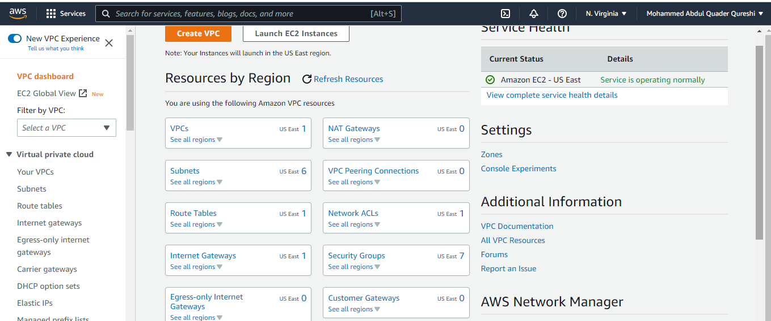

# Creating VPC – VPC only

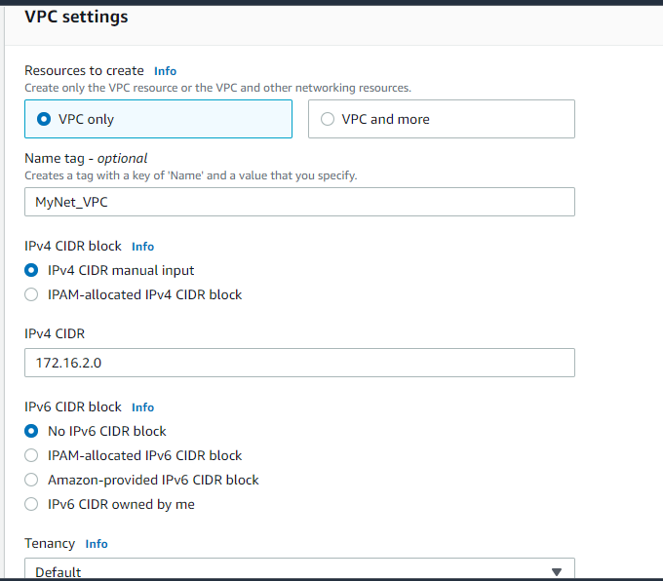

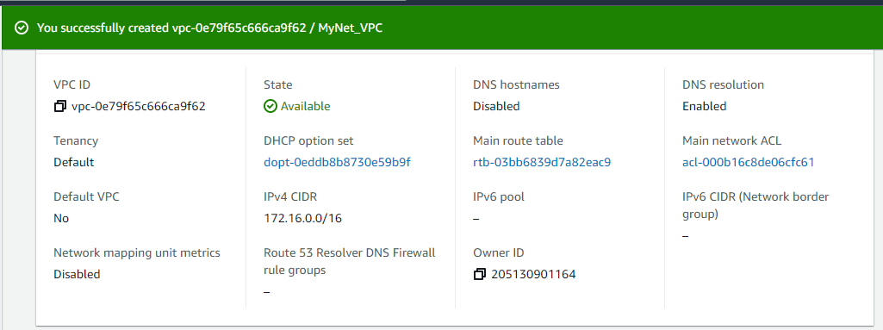

# Creating Subnets

|  |  |
| --- | --- |
| 172.16.2.0/24 | Bastion Host subnet |
| 172.16.4.0/24 | Webserver 1 |
| 172.16.8.0/24 | Appserver 1 |
| 172.16.16.0/24 | Database 1 |
| 172.16.32.0/24 | Webserver 2 |
| 172.16.64.0/24 | Appserver 2 |
| 172.16.128.0/24 | Database 2 |

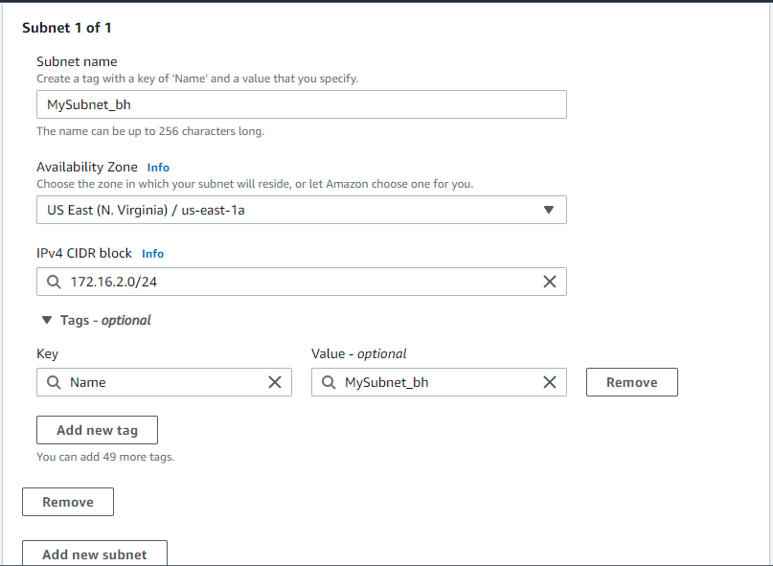

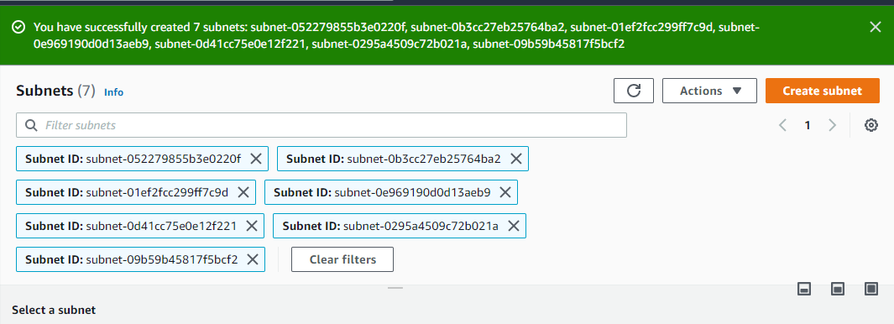

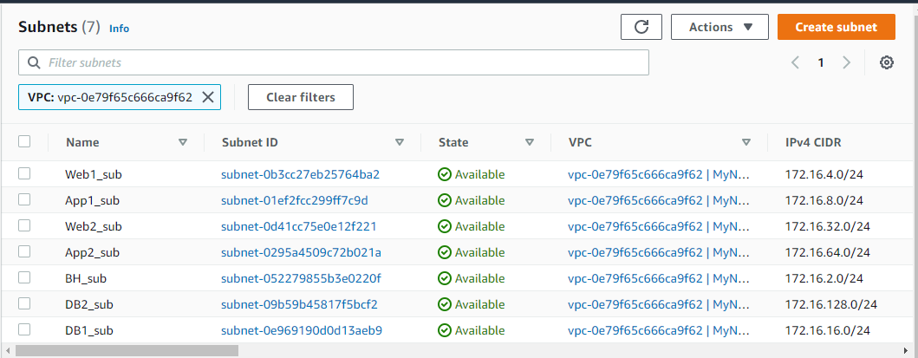

# Creating Internet Gateway and attach to MyNet_VPC

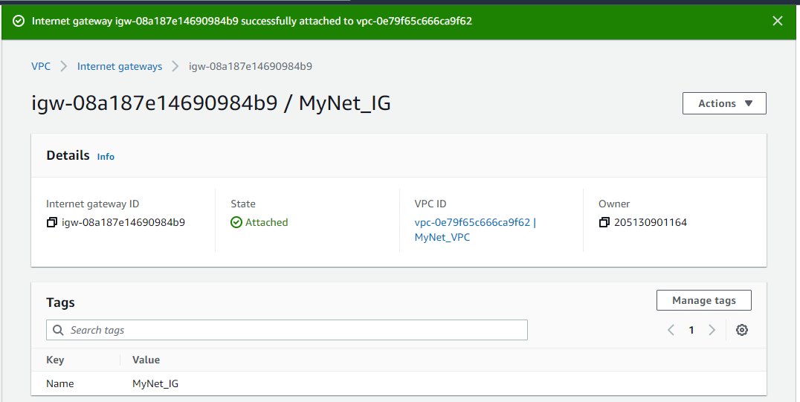

# Creating Routing Table—Edit routes—Subnet Associations

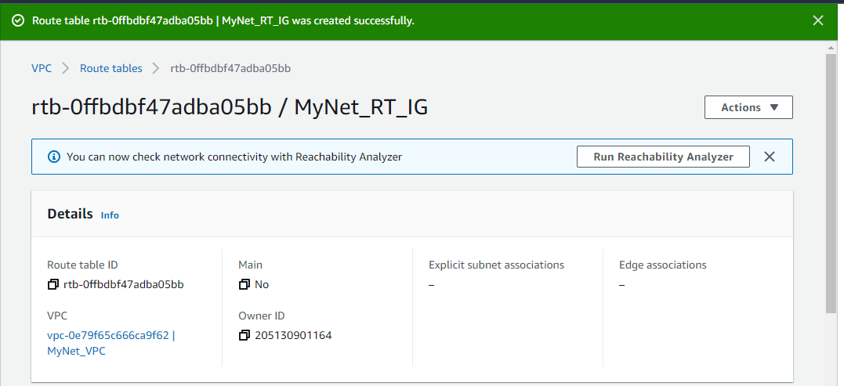

## Action – Edit Route

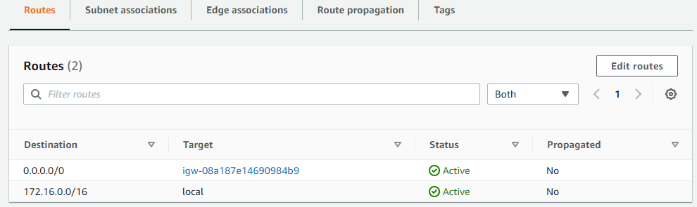

## Action --Edit Subnet Association (public) Bastion Host

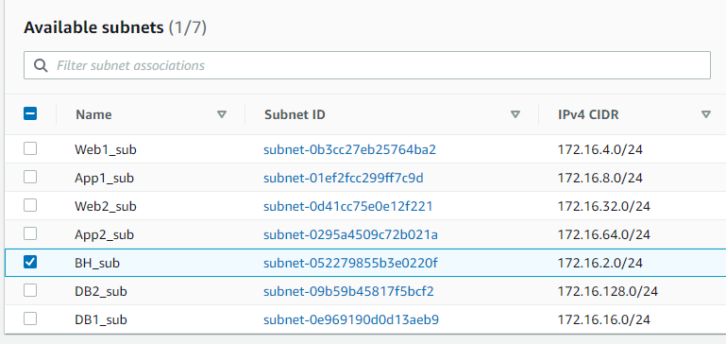

# Create NAT gateway – Allocating Elastic IP

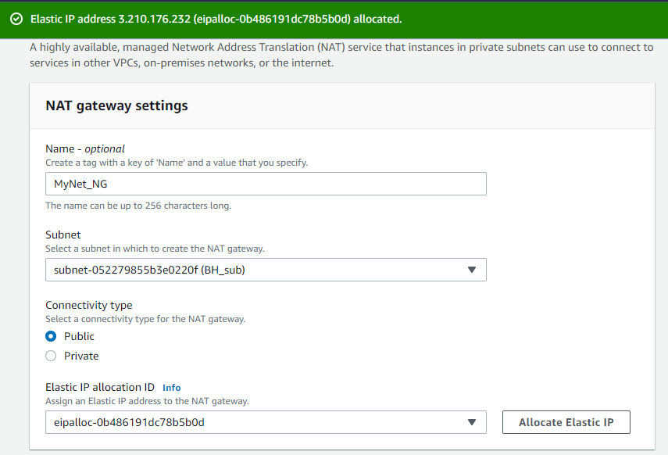

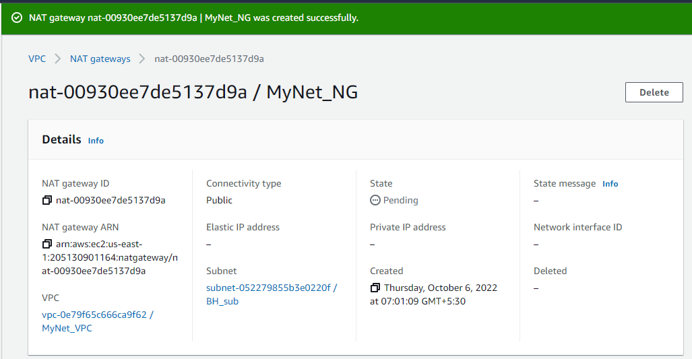

# Creating Routing Table for NAT gateway

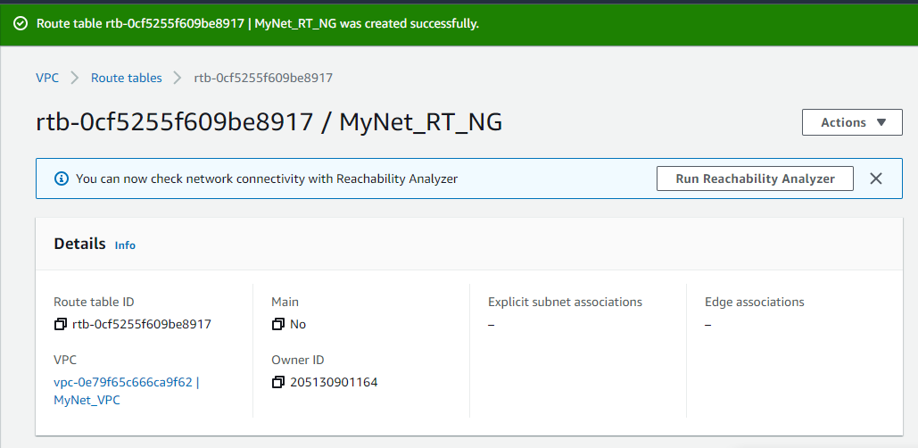

## Action – Edit Route

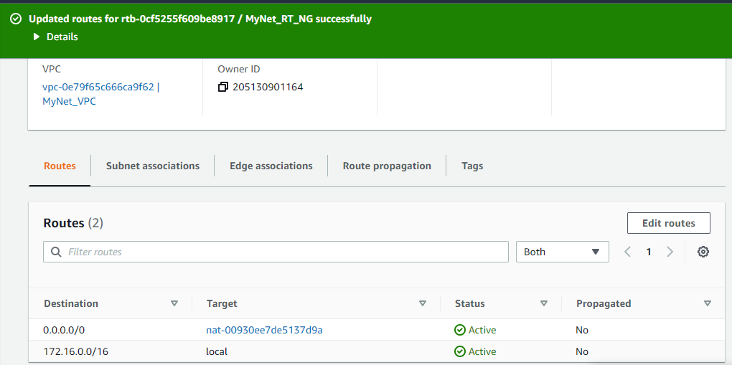

## Action – subnet association

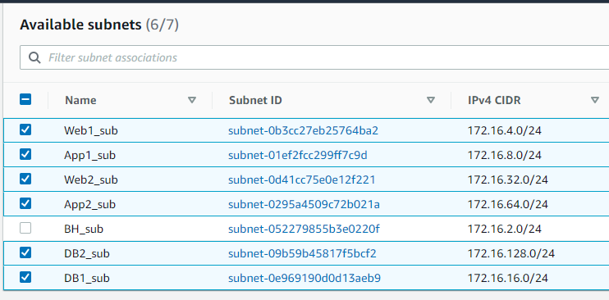

**Now,**

Launch EC2 instance Bastion Host then Webserver1 **with MyNet_VPC network**

Create individual Security Groups for Bastion Host and Webserver.

Enable Auto-assign-public IP from Subnet Settings for Bastion Host only.

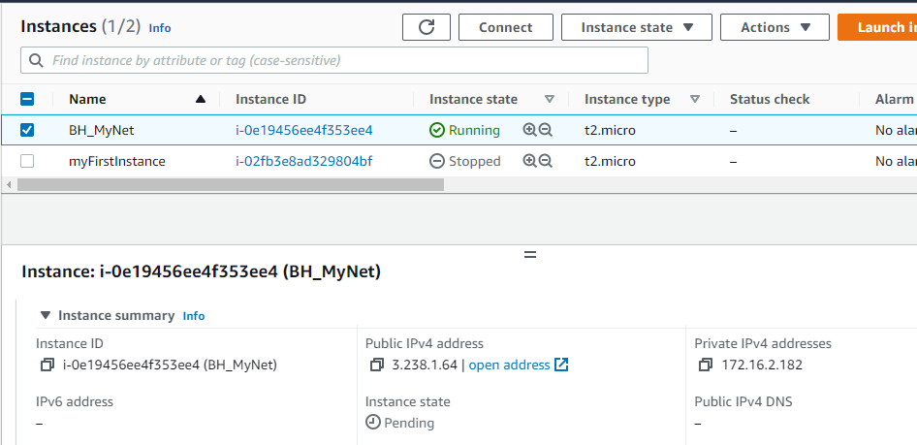

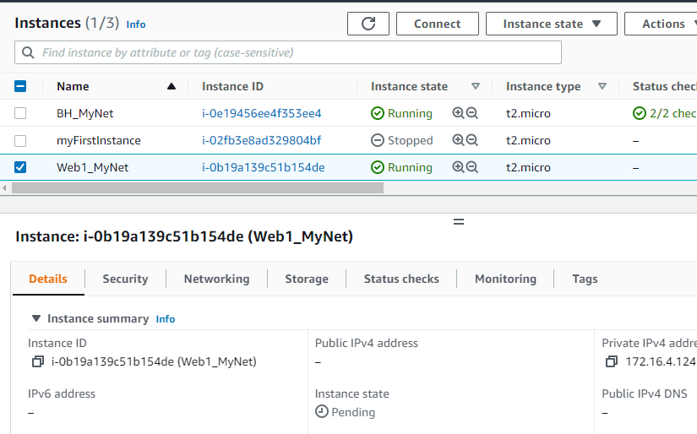

Generate using Putty private .ppk for Bastion host and Webserver1 host and connect.

# Use Pageant software as Putty agent to store .ppk and adhoc login to Webserver.

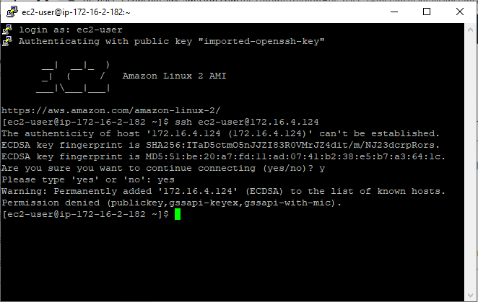

*Delete NAT gateway and then release Elastic IP to avoid cost.*

# **Peering VPC**

## Another VPC ‘MyAcceptor’ at Ohio Region

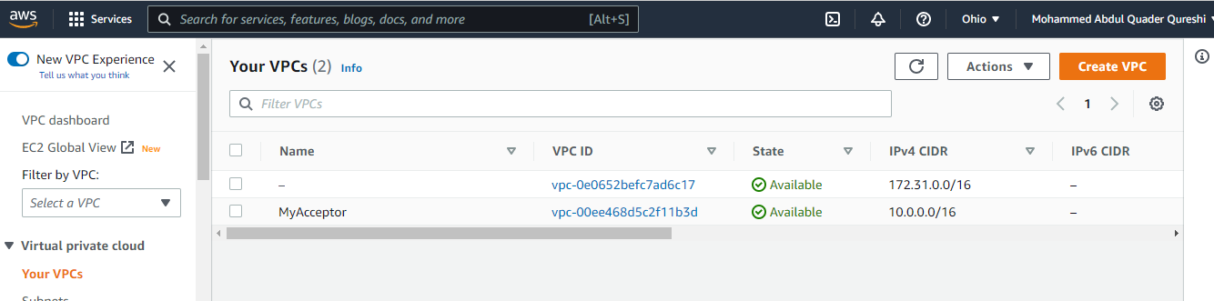

Two servers ‘Bastion Host’ and ‘Web1’ at Ohio Region

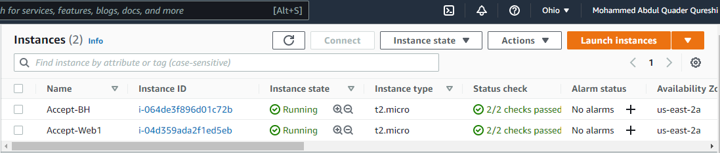

Connectivity to Web1 server from Bastion host

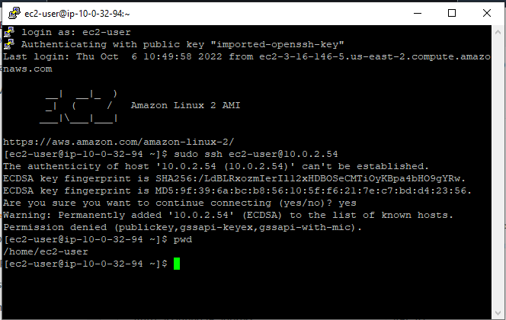

Now,

## Peering MyNet_VPC and MyAcceptor

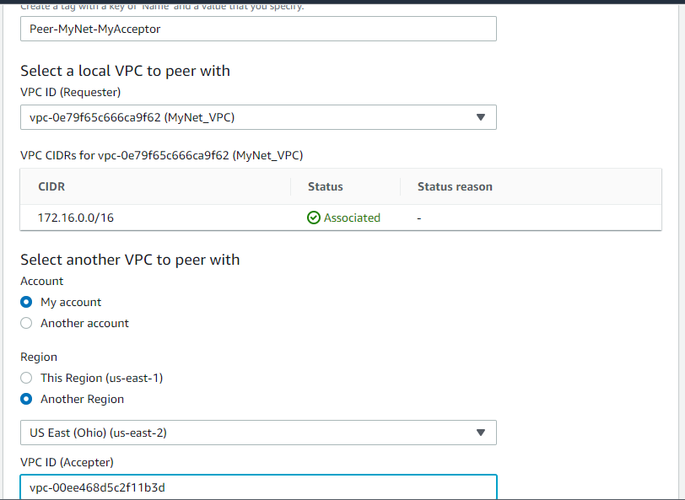

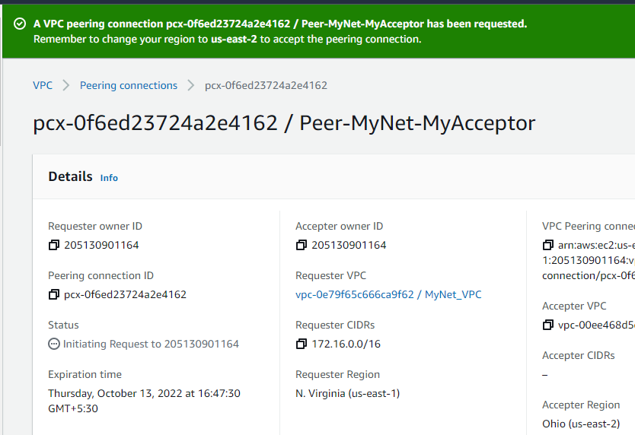

## Accept Request at Ohio VPC ‘MyAcceptor’

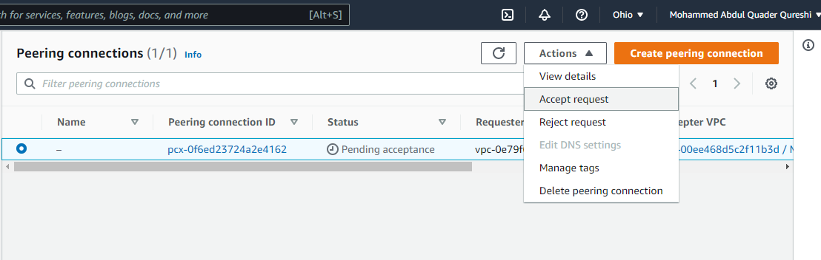

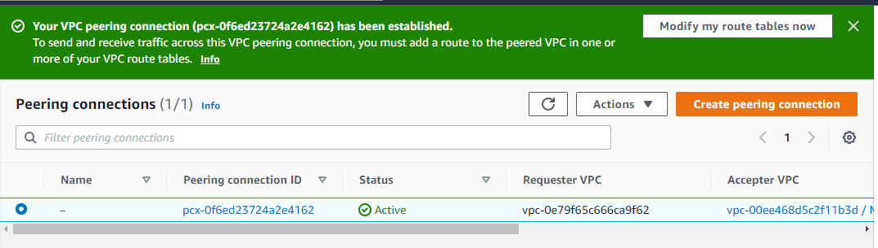

## Create Routing Table at Ohio MyAcceptor

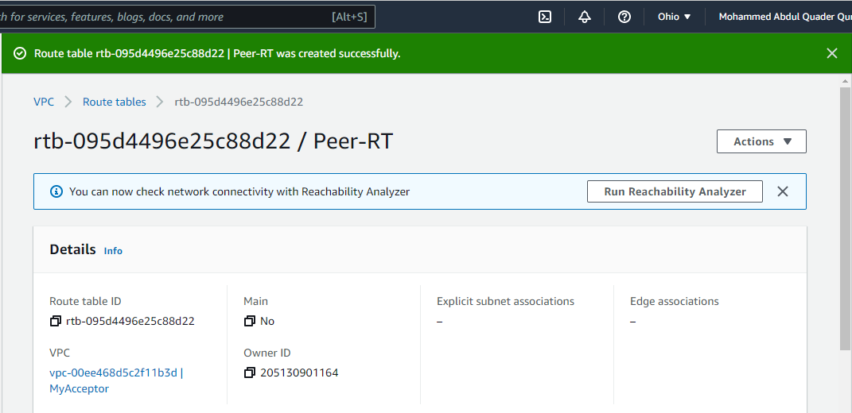

Edit Route

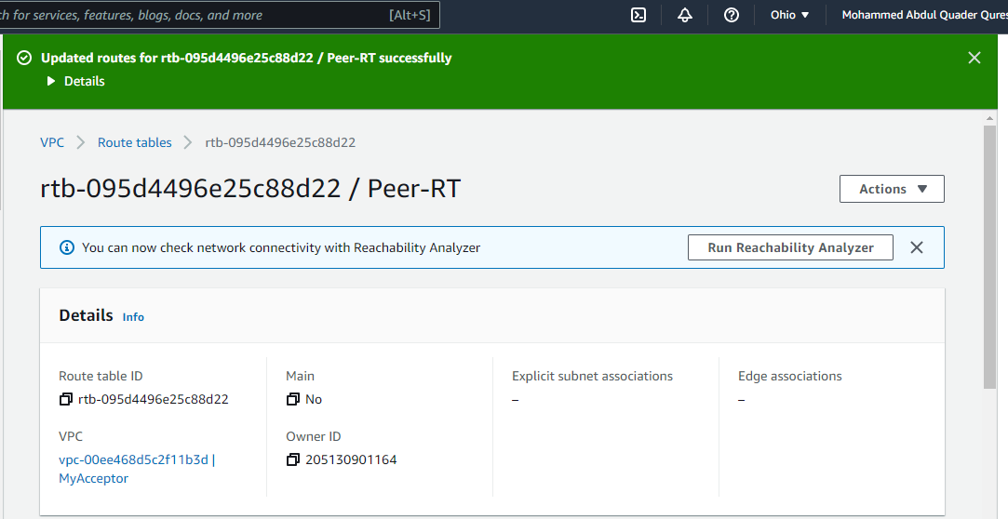

## Edit Association with Subnet “Accept-WebSub1”

